“Drone delivery” project definition

Task
You are working at Molecule and Chris, a product owner, approaches you. He got info from Nina, the
CTO, that Molecule has a very interesting lead with an Asian company selling an insurance product.
The product is a short-life policy that covers rentable short-range drone carriers from lift-off to
delivery. The prices of the policies are bound to the route of each delivery and are tracked real-time
by the drone’s aviation control system.
For that we have to augment our IT landscape with the next-generation, microservice-based solution,
that wraps around the well-functioning traditional core-system of the company. In addition, the old
core system needs extensive maintenance downtimes which have been done in the past during the
night and early morning hours. Due to the real-time requirements of the drone insurance and the
time zones differences such long downtime are no longer acceptable.

Core Functionalities
- Underwriting: To be able to roll-out personalized, AI driven real-time underwriting processes to the market
- Payments: Because the old system has problems integration new payment methods like cryptocurrencies.
- Documents: Because the old system is not supporting the latest version of holographic-technologies that they would like to add to their portfolio to compete with all the fancy startups out there

Business Functionalities
- If a policy is created, then we try to deduct the money from the customer’s account
- If the payment fails, then the policy is canceled
- If the payment is successful, then we send out the documents regarding the policy to the
customer
- In this case we send out two documents
- The legal policy contract containing the details of the policy
- An invoice about the purchase, containing the id and the price of the policy

Technical requirements
- The selling of policies must function even if the core is experiencing downtime.
- Policies and payments have to be synchronized back to the core system which is much slower than the other two systems.
- Documents do not have to be stored in the core system as they are not considered for legal audits.

Application structure overview
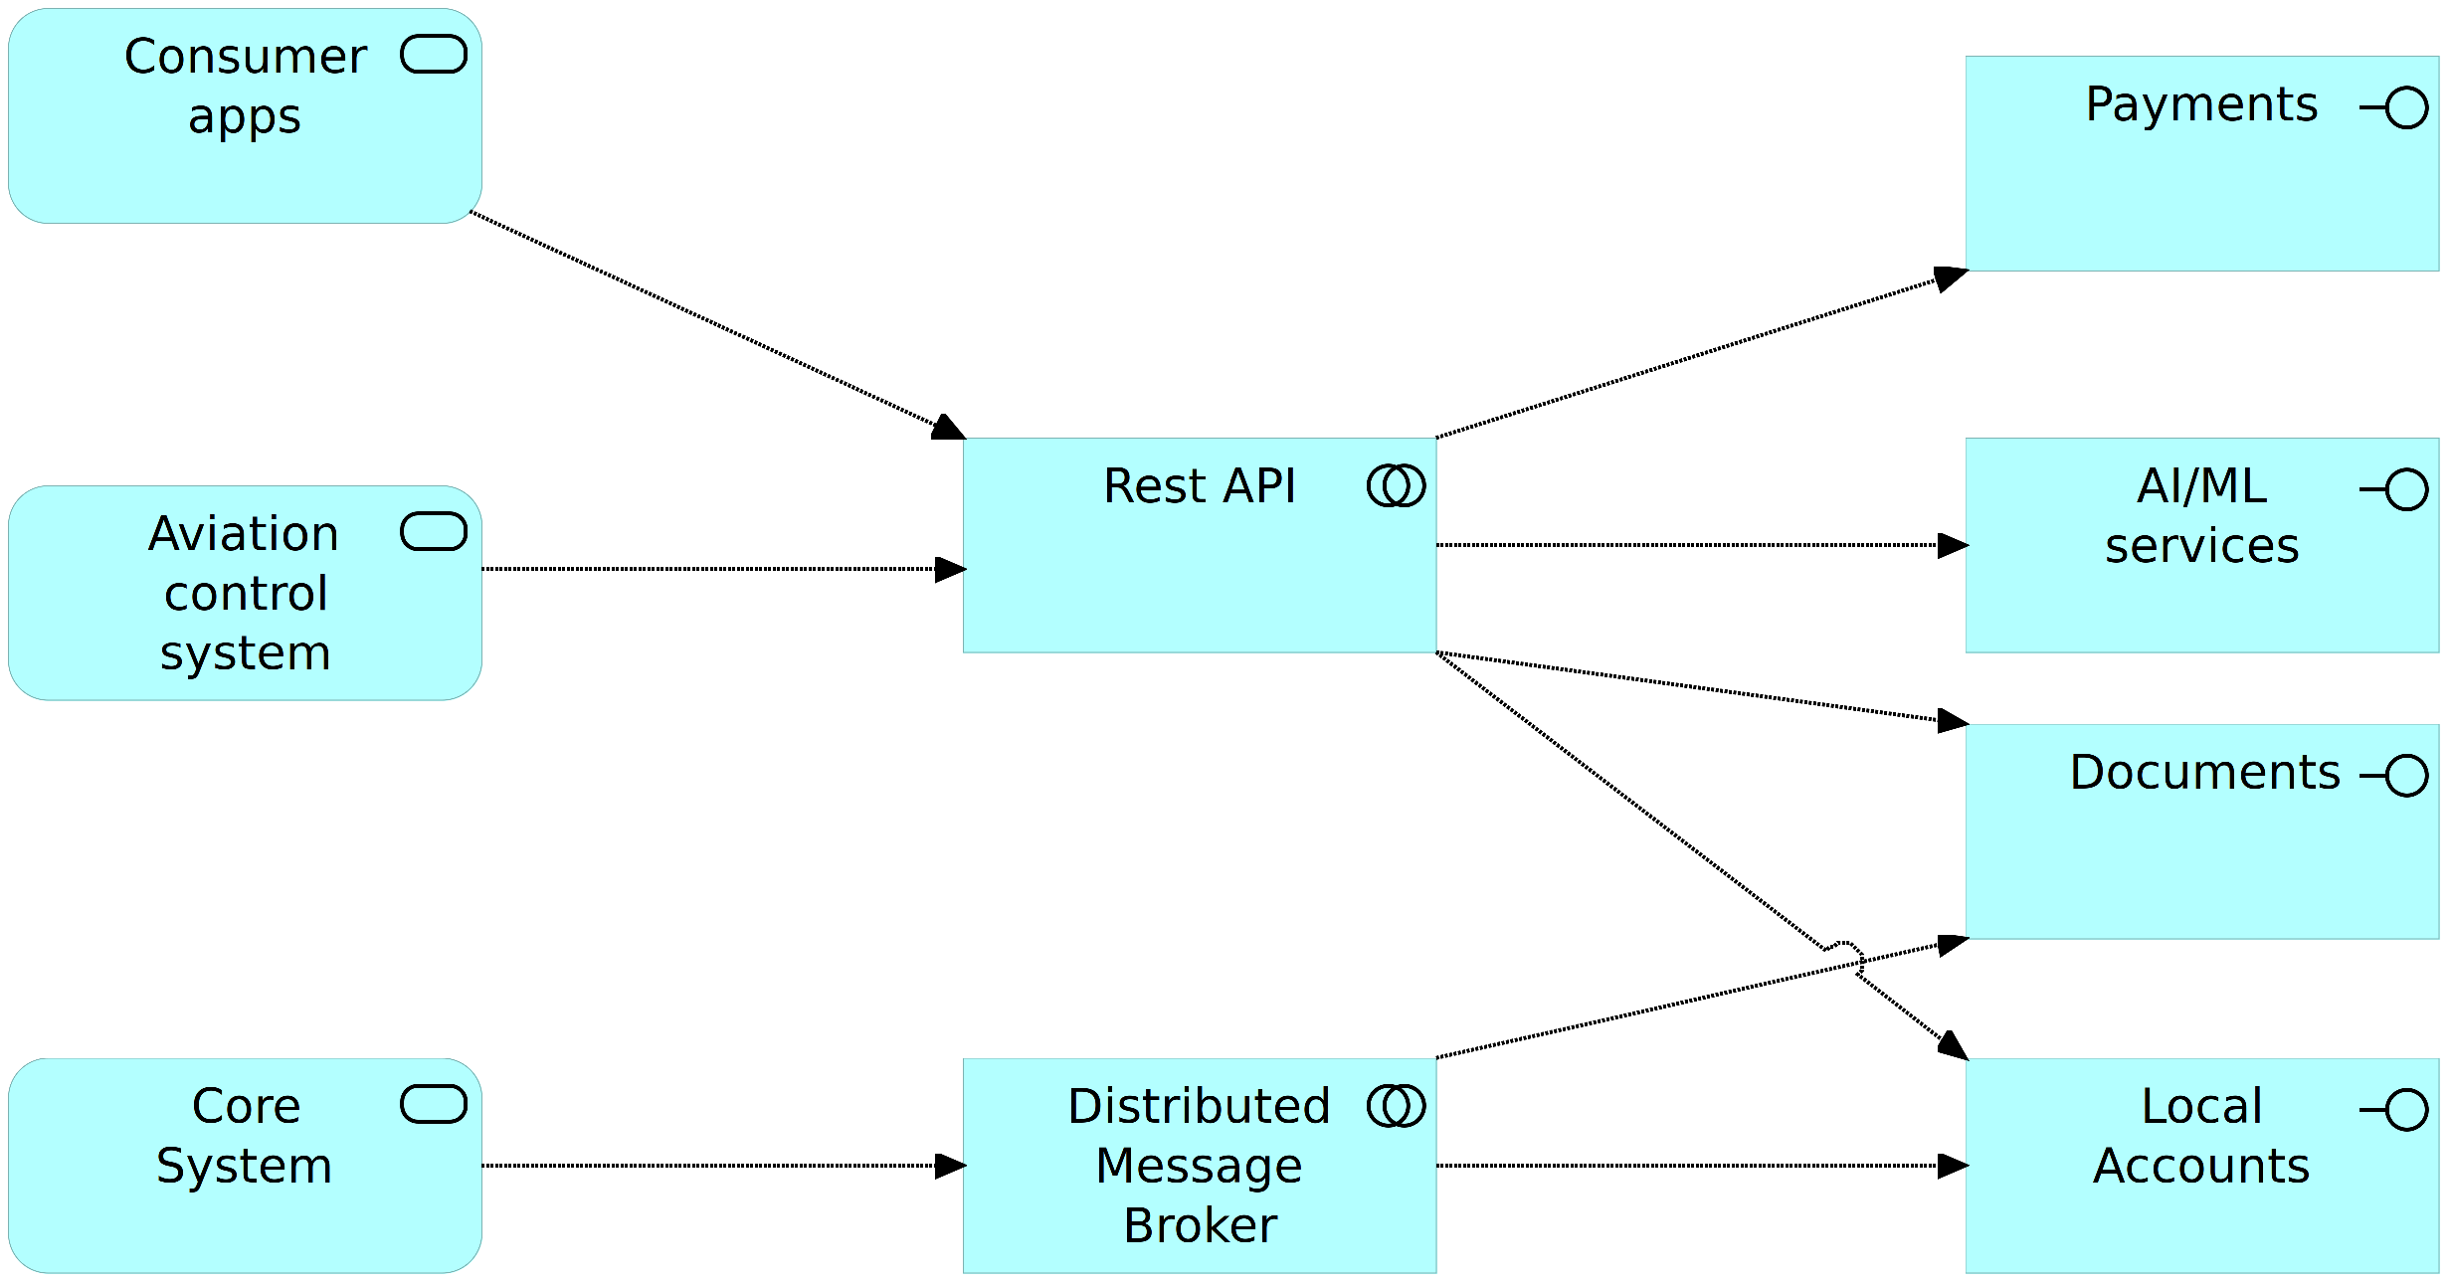

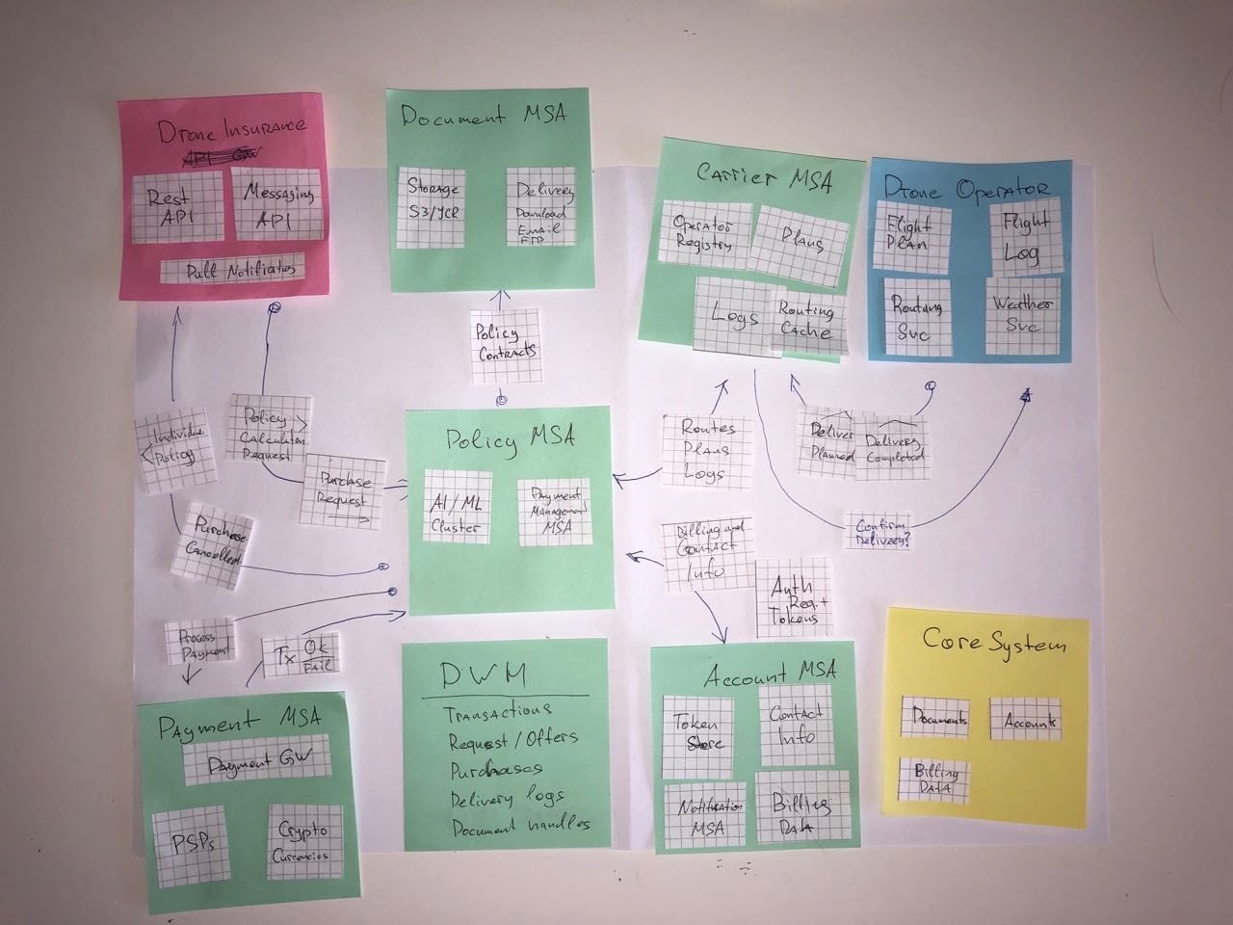
Initial design

Application components overview
